Inventory Management System

Block Diagram

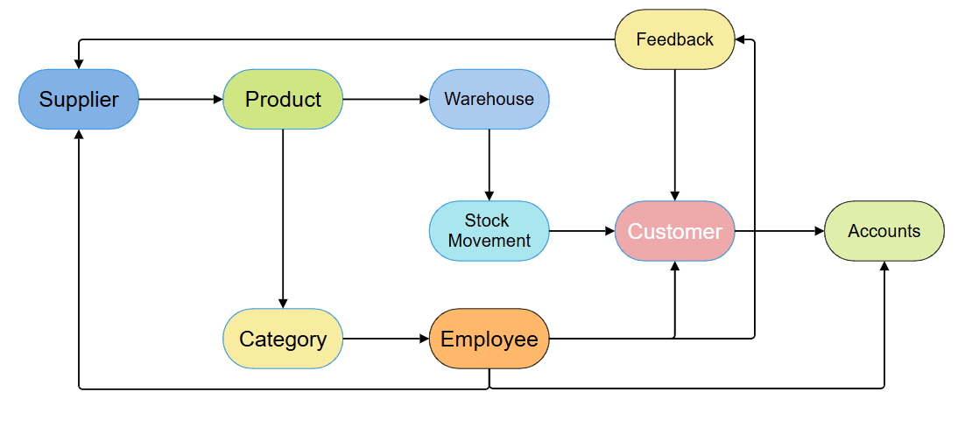
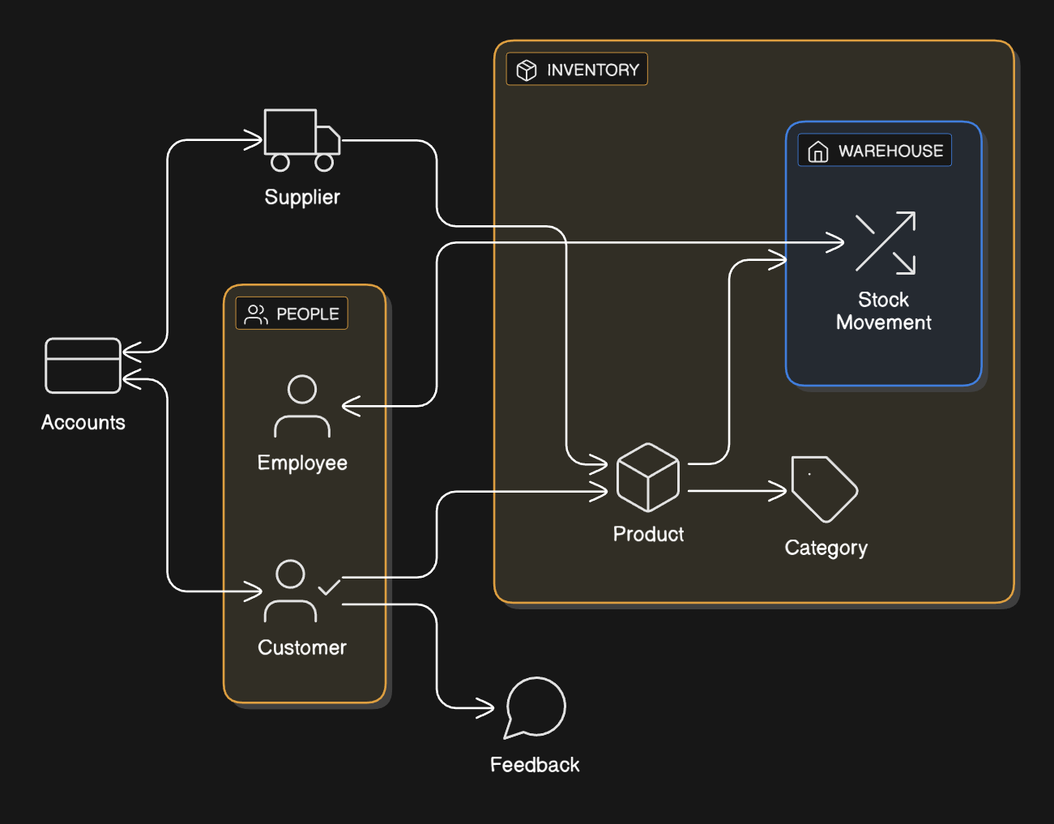

Schema Diagram

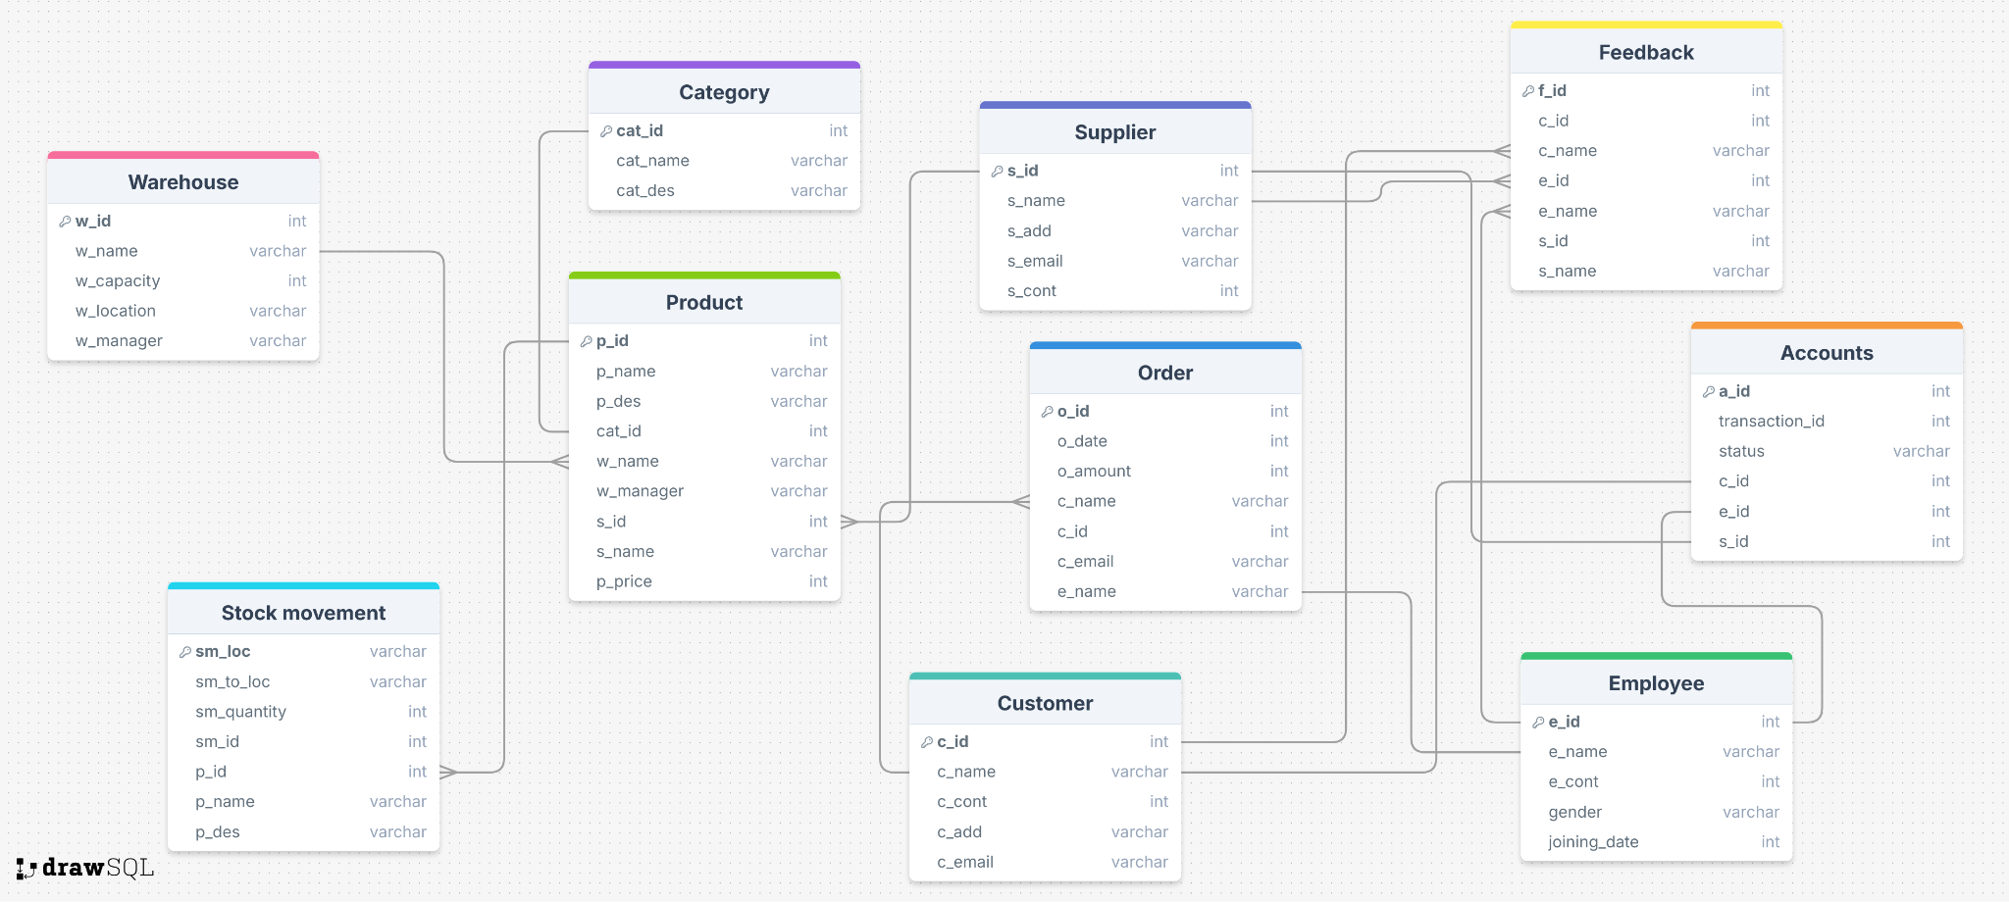

ER Diagram

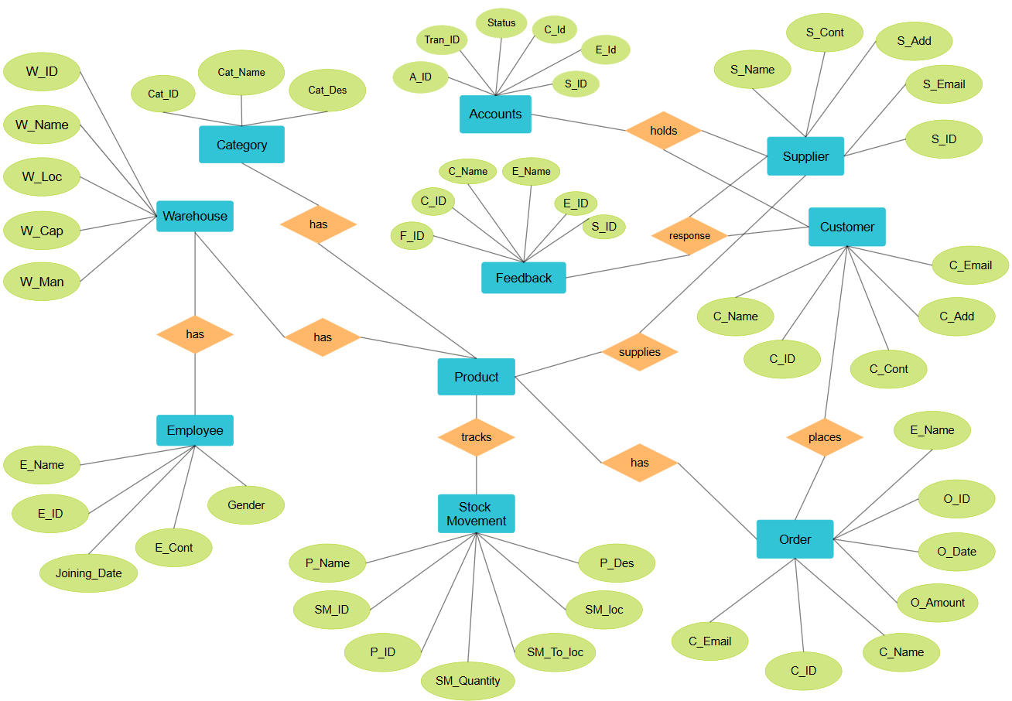

- Warehouse (1) —— (M) Product
- Warehouse (1) —— (M) Employee
- Category (1) —— (M) Product
- Supplier (1) —— (M) Product
- Customer (1) —— (M) Order
- Product (1) —— (M) Stock Movement
- Customer (1) —— (M) Feedback
- Supplier (1) —— (M) Customer
- Supplier (1) —— (M) Accounts

